Dear Altar Angels,

This has been a crazy year and I hope everyone is doing well. We are finally getting back to normalcy. I apologize for my lateness in getting this retreat finalized, seems like everything I have done this year has been late and for that I totally apologize. It is my hope that with this being my final year as director, we will have a wonderful turnout and a great time.

Check out our Face Book page: Diocese of Texas Altar Guild and EpiCenter.org/Altar Guild

Included are some protocols Camp Allen has initiated for our well-being. Please read as this information before hand, this way we are all informed.

I look forward to seeing each one of you this year.

Please complete the registration form and return as soon as possible.

Many Blessings

Mary Ann Conkel

Reminder: Gather any small linens that cannot be repaired for the linen burning service

Bring any questions you have for discussion.

Ask your rector about hosting a regional workshop at your church.

You can also check us out at epicenter.org and on Facebook: Diocese of Texas Altar Guild

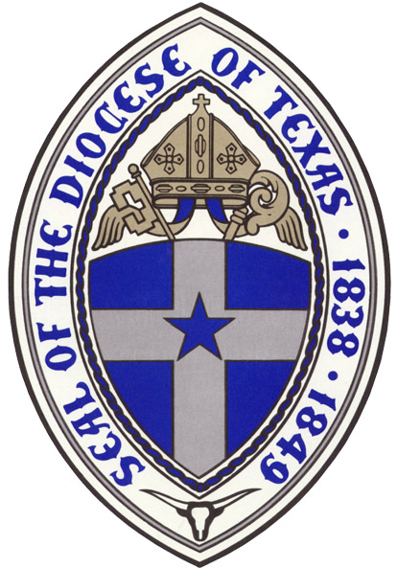

EPISCOPAL DIOCESE OF TEXAS
Altar Guild Retreat Registration
JUNE 17-19, 2021
Camp Allen, 18800 FM 352, Navasota, TX

Name: _______________________________________________________________

Address: _____________________________________________________________

Church/City: __________________________________________________________

Email: _______________________________________________________________

Telephone: Home ___________________ Cell: ___________________

Full Retreat: Thursday June 17, 2pm through lunch Saturday June 19 / circle your choice

Single per person: Thursday night $110.00 _____ Friday night $110.00 _____

Double per person Thursday night $ 80.00 _____ Friday night $ 80.00 _____

Name of Roommate: ___________________________ Please assign: ______

Friday only (includes lunch and dinner): $ 40.00.

Total enclosed: ___________ Registration due by June 10, 2021

Make checks payable to: Diocese of Texas Altar Guild and with registration form to:
Mary Ann Conkel, 1015 Herrera Ct, Hutto, TX 78634-5529
For questions: contact Mary Ann @ maconkel@gmail.com – 512-925-9758

For planning purposes, please circle the workshop you plan to attend:

A. Linen Care – Alice Scarborough

B. Needlework with Michele Roberts

This year make a piece of antique ecclesiastical brocade from Westminster come alive by adding gold bullion, and other gold and colored threads, beads, pearls, and sequins to the surface and learning how to mount it as a small box top. The antique brocade must be worked on a frame. Bring a small wooden needlepoint frame such as 8 x 8” or 8 x 10” plus the small box or picture frame you want to mount with the piece. Instructor will provide everything else. If you do not want to do a box top the brocade can be worked for a circular ornament and have custom beaded cording on the edge.

As in years past, kits for the "Stitching the Scriptures" biblical mottos will be available.

Bring embroidery scissors and a pencil. Bring additional light and magnification if you feel you may need it.) Kits include chart and instructions, embroidery fabric, embroidery threads, padding, mat boards, fabric backing, gold cord, gold braid, beads, lacing thread, and needles. Kit cost: $20.00 each.

Still available: cross stitch pattern of the Episcopal Shield (history and pattern, fabric, thread): $5.00

Every stitch is a prayer, including all the Prayer Shawls we knit. If you want to stop by and knit for a bit, join us in the stitching room. This year some of my stitching and knitting prayers are those of thankfulness for the Covid vaccine, and God’s protection.

C. Altar Guild 101 -

It is my intent to add another class for us to attend.

Payments for these workshops must be paid at the workshop directly to the presenter.

