Understanding Your Role as Pastoral Leaders
By the Rev. Dr. Dave Scheider, former director of the Louise Henderson Wessendorff Center for Christian Ministry and Vocations and lecturer in Counseling, Chaplaincy, and Spirituality, a U.S. Army chaplain for 25 years, and a counselor who specialized in family therapy

The Rev. Dr. Dave Scheider taught the following to chaplains so that they understood where they fit into the crisis team, which helped prevent feelings of being useless and powerless.

a. The Common Factors model by Miller, Duncan, and Hubbard for mental health counselors applies to clergy as well. Their research showed that what makes people well in mental health counseling is based on the common factors of:
1. The quality of the relationship with the professional,
2. Catharsis - feeling safe enough to unload troubling emotions,
3. Hope,
4. The counseling model the professional used, and
5. Extra-therapeutic events.

Notably, their research found that counseling theories were only slightly important to client healing, and that extra-therapeutic events like going to church, making friends, praying, etc. helped in client healing. Clergy bring to the table quality of relationship, hope, attention to feelings, and all the extra-therapeutic power unlocked at church and personal prayer. The message of common factors research helps clergy see our role as very important during times of crises.

b. Have a crisis counseling model that you have memorized and can use readily. I use Donna C. Aguilera's crisis intervention model, which is based on 3 balancing factors. If a person experiences stress, they can offset their stress to prevent it from spinning completely out of control by:
1. Having emotional support from people with whom they can be vulnerable,
2. Coping skills like prayer, exercise, etc., to get a break from the problem for brief periods, and
3. Interpreting the meaning of the event so that they can see what they can do about it (like the Serenity Prayer to change what they can, to accept what they can’t change, and wisdom to know the difference). This helps prevent overuse of limited energy on things that they can only accept. It helps with an internalized locus of control.

The message for clergy in this crisis model is that we can offer congregants small groups to provide emotional support, we can teach and provide coping skills in prayer and worship, and we are the primary leaders in providing meaning of events in our congregants’ lives during the crisis and at other times by preaching and teaching. For example, Christ Episcopal Church in Temple started small groups just before the pandemic and then switched the meetings to zoom. The groups have been studying the Way of Love curriculum. The clergy have included the practice of the week in the sermons and other messaging. These three strategies fit well with Aguilera’s three ways to counter stress with balancing factors.

4. Locate care receivers and family members on the transition model and plan to minister to where they are in the model. The transition model (from William Bridges’ book, Managing Transitions) is based on three phases: Endings, Neutral Zone, and New Beginnings. (See next page.)
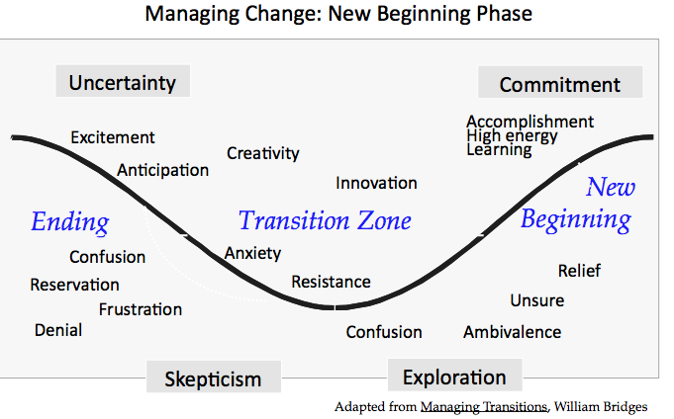
The messages for clergy in the transition model are:

- After every ending (crucifixion) there will be a new beginning (resurrection) but there will be a neutral zone (tomb) in between.

- Our culture loves to rush from endings to new beginnings and to skip the uncomfortable neutral zone. Clergy can be champions of lingering in liminal space of the neutral zone as a time for spiritual growth and getting scooped out creating more compassionate emotional space. Spiritual growth happens in the neutral zone.

- Each stage of the transition model tells us that we need different ministry strategies and skills. Think CPE training for endings, pastoral supportive counseling for neutral zone, and spiritual direction for new beginnings.

- The referral process. When referring parishioners for care with a mental health professional, remember it takes 3-4 visits before the hand off is complete. Beware the temptation to meet with a parishioner and think that the issue is resolved when you hand them a sticky note with the phone number of a counselor or human service. Most parishioners sweat blood with their issue before they meet with you. By the time they have made an appointment to seek help, they need more than a sticky note. The Clergy Manual wisely limit clergy to meeting with an individual only 3 or 4 times on an issue before referring the person to a professional counselor, but it’s important to follow up with the parishioner until they are firmly in the care of a counselor or other service. The chaplaincy refers to this as a warm hand-off.

What I typically do is I meet with the person once and if I give a referral, I just ask to see them again in a week. I ask them if it is ok for me to ask them in the next session if they have called the referral person. Usually the person takes several weeks to work through their resistance to moving to the next level. I don't meet with them in my office after the second session. The rest are me calling them at weekly intervals to ask how they are doing and if they have reached the next level. So, the first two sessions are pastoral counseling. The rest of the accountability calls are pastoral care.

